
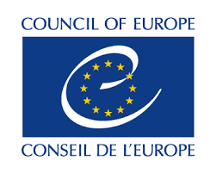
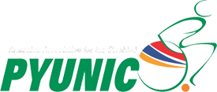
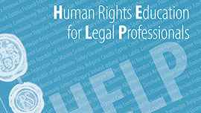
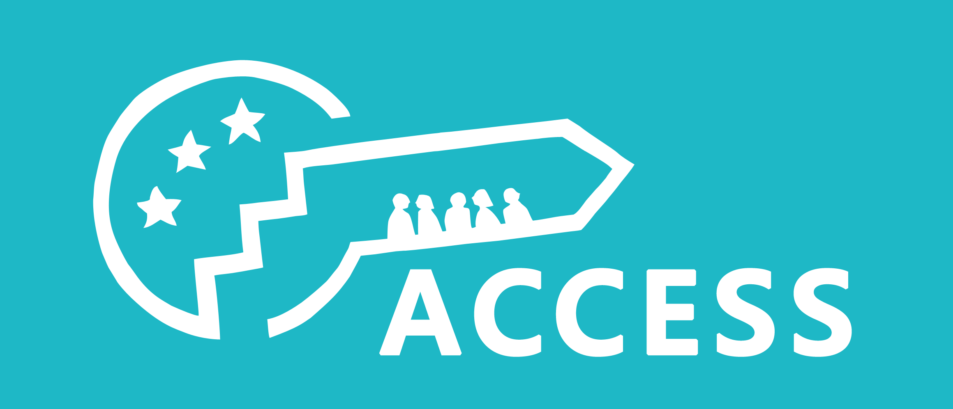

CALL FOR LEGAL PROFESSIONALS

A TUTORED DISTANCE LEARNING COURSE
ON THE RIGHTS OF PERSONS WITH DISABILITIES
UNDER THE HELP PLATFORM

26 February, 2018
Yerevan, Armenia

The Armenian Association for the Disabled ''Pyunic'' (Pyunic NGO, Yerevan, Armenia) and its international partner, the Advocacy Centre on Council of Europe Standards (ACCESS, Strasbourg, France), are launching a call for trainees for a tutored distance learning course on the rights of persons with disabilities, developed in close collaboration with the Council of Europe's (CoE) European Programme for Human Rights Education for Legal Professionals (HELP). The course duration is 10 weeks and it is scheduled to take place between April 3 – June 11, 2018.

The tutored course is designed for the learning needs of Armenia-based and Armenian-speaking legal professionals working in the field of the rights of persons with disabilities (both mental and physical) and cross-cutting issues.

The online training is organised within the framework of the project ''Promoting the social rights of persons with disabilities by building the capacity of Armenian civil society organisations to engage with the CoE monitoring mechanisms", funded by the European Union.

Interested professionals must send their curriculum vitae (CV) by e-mail to rsarg@mail.com, by 9 March, midday (Yerevan Time). Applications can be written both in Armenian and in English.

Below you may read more information about the course and the implementing organisations.

1. The e-learning course on the rights of persons with disabilities and its Armenian adaptation

The model English e-learning course on the rights of persons with disabilities has been developed by ACCESS in close cooperation with the HELP Programme Secretariat. In 2017, two ACCESS international experts on the rights of persons with disabilities prepared the training material in English. The model course is open to any user who creates an account on the HELP platform, making it free and available to anyone with a computer and internet.

The course will have two adaptations in the Armenian language: one for legal professionals, judges and government officials working on the rights of persons with disabilities and cross-cutting issues in Armenia, and adaptation for members of Armenian civil society organisations.

This distance course has been tailored to meet the learning needs of legal professionals working on the rights of persons with disabilities in Armenia, by using the HELP training methodology and resources. Legal professionals are at the front line in that respect, with their work being of critical importance in ensuring the effective and efficient protection of the rights of persons with disabilities under relevant international legal standards.

The course participants will benefit both from a face-to-face training and distance learning, led and guided by a National Tutor. The distance course is composed of the following modules which correspond to the priorities established in the CoE Disability Strategy 2017-2023:

- Introductory module;
- Non-discrimination and intersectionality;
- Legal capacity and independent living;
- Accessibility and independent living;
- Social rights of persons with disabilities.

The participants will receive all necessary information and technical support throughout the implementation of the course. They will be invited to a kick-off meeting with the National Tutor (the date and the venue of the meeting will be announced shortly) to get practical details on the course and its methodology.

2.What are the benefits of taking this distance course?

The proposed e-learning course stands out in two important ways: it will be the first HELP course targeting legal professionals working on disability rights in Armenia, and it will be the first fully-fledged course on the rights of persons with disabilities in the HELP curriculum. Moreover, the course will be available in accessible formats in order to make sure that everyone can benefit from it. Its central aim will be to increase the knowledge of legal professionals and other relevant stakeholders in Armenia on the applicable international and CoE standards. This will be achieved by a complementary set of trainings, combining a 10-week distance learning course based on the innovative methodology of the HELP Programme via the online HELP platform, and supplemented by a face-to-face training session with participants at the beginning of the course.

At the end of the course, the participants will be able to:

- Identify and compare international standards on rights of persons with disabilities under the UN Convention on the Rights of Persons with Disabilities (UNCRPD) and the CoE instruments (European Convention on Human Rights – ECHR, the revised European Social Charter- ESC(r) and soft law documents),
- Understand and distinguish the role of European actors in protecting and promoting the rights of persons with disabilities, with a focus on the role of the European Court on Human Rights (ECtHR), and the European Committee of Social Rights (ECSR),
- Apply in legal practice the relevant provisions of the ECHR, ESC(r) and other European standards for a better protection of the rights of persons with disabilities,
- Become certified trainees by getting attendance certificates from the CoE HELP Programme. The most successful trainees will be inserted in a list of certified HELP trainers so that in the future both Council of Europe offices and national training institutions could involve them into national or international activities on the ECHR.

Each module consists of a set of assignments and tests featuring multiple choice questions, allowing the participants to review the training material, as well as to build up arguments on relevant case law under the UNCRPD, the CoE instruments (ECHR, ESC(r) and soft law documents) and the European Court of Human Rights (ECtHR) .

3. The profile of the participants

The tutored distance course is organised for Armenia-based and Armenian-speaking legal professionals (certified lawyers, judges, prosecutors, government officials and professionals representing the RA Human Rights Defender's Staff) working in the field of the rights of persons with disabilities (both mental and physical) and cross-cutting issues. The participants must:

- Be committed to support the advancement of the rights of persons with disabilities in Armenia;
- Show prior involvement and interest in promoting the rights of persons with disabilities at national or international levels;
- Be motivated to practice in their work the international standards on the rights of persons with disabilities by using the relevant UN and CoE instruments;
- Be able to spend at least 4 hours per week on each module of the course, by duly completing the course assignments and engaging into discussion with other participants on the course forum;
- Have a very good knowledge of Armenian (the knowledge of English is a plus)

4. About the Council of Europe HELP Programme

The HELP Programme supports the CoE member States in implementing the ECHR and other CoE human rights standards. This is done by enhancing the capacity of judges, lawyers and prosecutors in all 47 member states to apply the ECHR and other CoE standards such as the ESC(r). In brief, HELP is:

- an e-learning platform on human rights;
- a human rights training methodology for legal professionals;
- the only pan-European network of national training institutions for judges, prosecutors and lawyers in the 47 CoE member States.

More information on the HELP Programme and its courses can be found at http://www.coe.int/en/web/help/help-training-platform.

5. About the project

Combining the expertise of the Yerevan-based Pyunic NGO on the situation and challenges faced by persons with disabilities in Armenia, and that of ACCESS on building the capacity of national civil society organisations to promote the implementation of human rights through the CoE, the two partner NGOs have designed a project to bridge the gap between Armenia's NGOs and European institutions and human rights standards.

This two year-long project aims to achieve the following specific objectives:

- To increase awareness of civil society on European and international standards and procedures on the protection of social rights of persons with disabilities;
- To enhance the capacity of civil society in Armenia to sustainably and autonomously participate in and report to the CoE monitoring mechanisms, and in particular the ESC(r);
- To promote dialogue on the ratification of the ESC(r) complaints mechanism and its additional provisions;
- To raise awareness on the multiple discrimination and violence faced by persons with disabilities, including women, children, seniors and migrants.

6. Application

Interested candidates must send their curriculum vitae (CV) by e-mail to rsarg@mail.com, by 9 March, midday (Yerevan Time). All the documents should be sent in a Word or PDF format. Applications can be written both in Armenian and in English.

For more information about the training course, contact the project manager Ruzanna Sargsyan at rsarg@mail.com.

